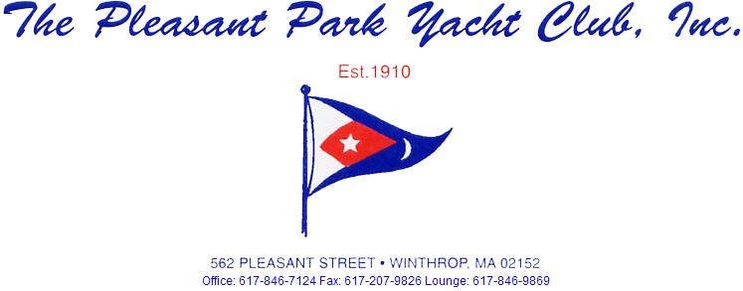
Commodore: Angelo Troisi, Vice Commodore: Ron Ahlquist, Rear Commodore: Steve Ruzzo Secretary: Michael Lopez Treasurer: David Connors
Board of Directors: James Prendergast, David Catalano, Sean Watson and Dana Ringdal
Dear PPYC Member,
The next Membership meeting will be held on Tuesday, Feb 6, 2018 at 7:00PM. I hope you enjoy this newsletter as it is my first. In the future I would like to make a few changes to the layout and add more comments / letters from the various chairs. A work in the making. I would love to go paperless, any member who receives this newsletter by mail please contact me with your email address so I can send out this newsletter via email. You can contact me by secretary.ppyc@gmail.com In going paperless, this will not only save the club money but it will also allow me to include more photos become more visual and incorporate more content. I would also like to upload the letter to our club website so anyone who doesn't have email will be able to go onto the website and be able to access it that way. I will still print a hard copy to be placed in the bar for all to read. If you don't have access to email, let alone a way to look at our club website, I will continue to mail you the Newsletter. If you could call the office and leave a message with your name and mailing address and just state you want to continue to receive the newsletter by mail I will more than happy to accommodate. Im just looking for away to cut back and also to utilize the technology available. I would also like to continue to update both the website along with the ppyc Facebook account with upcoming events.
Also, in improving the Communications aspect of the club I would like to start a “Letters to the Commodore” section of the newsletter. This is where you could write, or call in, a comment / question to the commodore, and I would place it along with the commodores response in the next newsletter. I would like to have a trial run for next newsletter, so any comments questions or suggestions to the commodore send them to secretary.ppyc@gmail.com and place in the subject line “Letters to the Commodore”
Enjoy this months Letter.
Michael Lopez
PPYC Secretary

Entertainment:
Our first club event will be on Sat Feb 17th.
Annual summer in the winter party.
Break out the flip flops and Hawaiin shirts.
The downstairs bar will open at 6PM and
Chinese food will be served around 7PM.
We will have a DJ Jimmy Lagrasso.
20$ per person.
There will be a sign up sheet posted.
Last year was a great success!

Float:
Winter wet storage still available. You must have a bubbler and all boats must be winterized. No block heaters!
As stated in Float Rule 39: All boat owners must havea mandatory insurance liability requirement of $300,000.00 per boat and proof must be submitted to the Float Committee before a boat is allowed on the floats. This is required by our club insurance policy. No insurance, no float space! All Insurance Policies are required to be on file at the club for all boats. Have your insurance agent fax your insurance cover page to the club at (617) 207-9826, or drop a copy off at the office, or email club secretary. PLEASE UPDATE INSURANCE POLICIES!
Prior to going out to the docks during this harsh season, PLEASE either utilize the buddy system or go upstairs and notify the bartender you are going out and your expected time of return. Also please do not forget to return to the bar and report back in.
Its been a very tough winter around the docks, I would like to thank Dave Catalano, Bob Cataldo, , Dana Ringdahl, Angelo Troisi, Ron Alquist, Mark Morgan, Mark Moran, Paul Levy all for breaking ice, shoveling docks, freeing up the bubblers, and overall keeping a watchful eye on the docks. As well as all of the people in winter wet storage I would like to thank them for keeping there bubblers running and there areas clear.
I would also like to recognize Tony Leone for offering his help with breaking ice on the docks. However, I could not accept his help knowing that he is still undergoing much needed rehab due to his shoulder. We, on the float committee extremely appreciate his offer and it doesn’t go unnoticed.

Thank you very much

Float Chair P.C. Jim Lawrence JR

Yard:

Thank you for all that adhered to the parking ban over the storm. We were able to clear the parking lot much easier without trying to plow around cars. I understand it was an inconvenience to all, I am truly grateful for the cooperation. Please, in the future, if there is any kind of plowable snow, park off site. Any plowable snow, your subject to tow! This allows us to ensure a safe lot for all. Volunteers are encouraged to assist in snow/ice removal of our sidewalks surrounding our property, contact myself, house committee, or the club secretary. No drop date for the boats yet, stay tuned. Summer can't come fast enough.

Sean Watson
Yard Chair

Upcoming Events
February 17 2018 - SUMMER IN THE WINTER PARTY

Sunshine Committee.
Please email secretary.ppyc@gmail.com with any updates or condolences related to our Members or their family
As always we are looking for volunteers in all skill sets for our committees. If you need any Chairperson Contact information please let us know.
PPYC‘s E-MAIL address: secretary.Ppyc@gmail.com

Commodore’s Message
Fellow Members,
I'm pleased to serve as your Commodore in 2018 and wish to congratulate the new Bridge and Directors for their election victories and for your vote of confidence. We had a good election turnout and you should take pride in that participation.
As Past Commodore Kevin Kneeland reported in the last newsletter, there are many projects in transition that we hope to complete this year. We have an outstanding Board and all members are working on projects to move the club ahead. Among them are the finalization of the year-long project to purchase Capt. Jack's Marina, bring to fruition the solution to an all-season climate system that would include heat and cooling, and implementing a higher level of security to the club, its members and their costly assets. Some of the projects will require your vote and we hope that your participation will be enthusiastic.
We look forward to all of your contributions, large or small, to the many committees that serve the club to make it better for all.
We've had a few weeks of cold weather and storms. I'd like to give a special congratulations to the Float Committee for the many hours spent in clearing ice and doing all to protect the marina from severe damage.
This Board's agenda aims for transparency and integrity as its guiding principles. Feel free to approach any of us if you have questions or concerns. If we don't have an answer we will strive, as a group, to research and find the answer.
Lastly, may 2018 be healthy, happy and successful for all.
Angelo Troisi
Commodore

